# Nutrient Sensitive Areas Analysis

Jason Nemecek, Travis Rome, Laura Morton

There is also a module in Conservation Desktop that conservationists use in the pre-planning process working with producers on their land. They can run scenarios and help scope the conservation plan and the options for the producers based on their soils and land capabilities and limitations.

One new tool that we developed for the conservation planners is [***the Nutrient Sensitive Areas Analysis - Soil Sensitivity (Nutrient Runoff) pre-planning tool***](https://www.nrcs.usda.gov/news/nrcs-refines-nutrient-management-strategies-to-improve-conservation-outcomes#:~:text=This%20plan%20includes%20promoting%20SMART%20Nutrient%20Management%20planning,and%20NRCS%20continues%20to%20move%20this%20work%20forward.). This model provides a science-based methodology, a tool and visualization for the conservationists to use with clients in Conservation Desktop. Conservationists can use this pre-planning tool and map to assist clients with a plan to reduce nutrient runoff from their operations. Conservation planners will be able to select practices and fields to run the sensitivity analysis to help with planning alternatives. Results of the sensitivity analysis will be stored for future use within the CART assessment and ranking process. The Conservation Products module will retrieve the results and develop a map and report and to provide to the client with information for planning practices on their operation.

Purpose:

To support the NRCS SMART Nutrient Management initiative, a soil sensitivity index (interpretation) was developed to rate soils based on their sensitivity for nutrient runoff. The index can be used in conservation planning to assist in identifying soils and areas with greater vulnerability to nutrient runoff. The most sensitive soils are those that are most vulnerable, or highly susceptible to nutrient runoff.

Nutrient Sensitive Areas Analysis – The Soil Sensitivity (Nutrient Runoff) model provides a science-based methodology, a tool and visualization for the conservationists to use with clients in Conservation Desktop. Conservationists can use this pre-planning tool and map to assist clients with a plan to reduce nutrient runoff from their operations.   Conservation planners will be able to select practices and fields to run the sensitivity analysis to help with planning alternatives. Results of the sensitivity analysis will be stored for future use within the CART assessment and ranking process.  The Conservation Products module will retrieve the results and develop a map and report and to provide to the client with information for planning practices on their operation.

Develop a science-based tool to for pre-planning work with clients so that conservation planners can view a map with clear ratings that show fields with different potential for nutrient runoff.  Conservation Planners will be able to select practices and land units to run the sensitivity analysis.  Results of the sensitivity analysis will be stored for future use within the CART assessment and ranking process.  The Conservation Products module will be able retrieve the results and provide the planner and client a map and related information for planning practices.

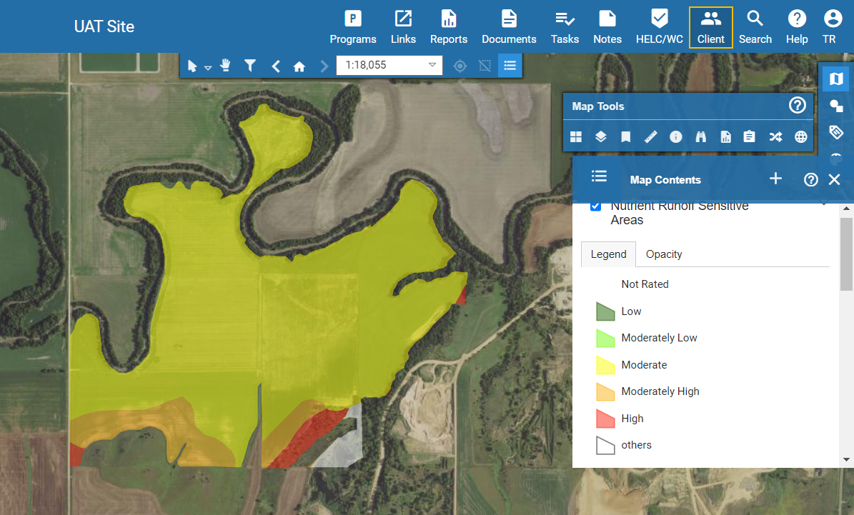

***Figure 1. Screenshot of Conservation Desktop showing the Soil Sensitivity Analysis model run on a planned landunit.***

Sometime this year the Soil Sensitive Sensitivity will have additional enhancements that will include additional spatial enhancements such as terrain derivatives.

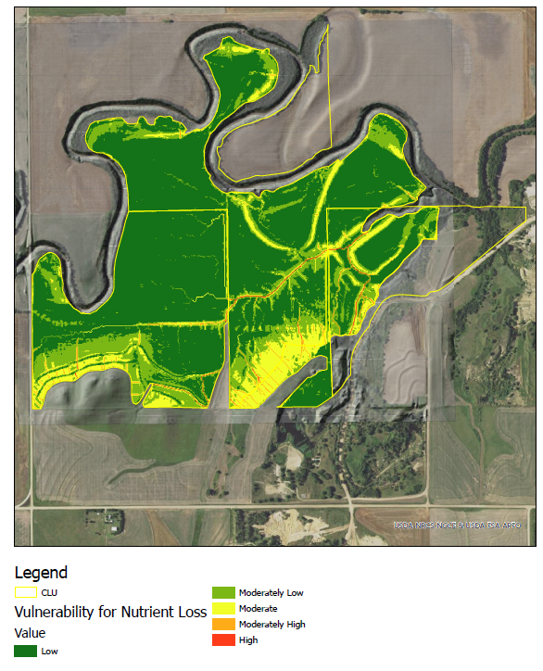

Figure 2. Prototype with the terrain derivatives enhancements.